To (department acronym name) |  | For information (department acronym name)
EPSD

StyleCop GuidelinesStyleCop Guidelines

Background 1
StyleCop 2
Adding StyleCop to a solution 2
Working with legacy code 2
Suppressing Warnings 2
SuppressMessage 2
Settings file 3
When should warnings be suppressed? 3
Global suppressions 3
References 5

Background
The document addresses the overall guidelines for using the StyleCop tool. However, it does not intend to fill the function of a technical manual for the tool.
The target audience is developers at EPSD.

StyleCop

Adding StyleCop to a solution

Right-click the node at the top of Solution Explorer and select Manage NuGet Packages for Solution. Add StyleCop.Error.MSBuild (used to make warnings appear as erros) packages. Settings.StyleCop is added under Solution Settings in Solution Explorer. It should be at the same level as the .sln file in the file structure. The settings apply to all projects in the current solution.

Working with legacy code
When you enable StyleCop on legacy code, it may be necessary to override Settings.StyleCop located at root level if you don’t want to fix all the warnings at the same time. Then you can disable warnings that you want to fix later.

You can override the settings at the solution-level by having one Settings.StyleCop file per project. These files are created when you click StyleCop Settings from the project level in Solution Explorer - they are not added to the project file.

Suppressing Warnings
There are three ways to suppress warnings in StyleCop:
- Use the SuppressMessage attribute.
- Use a StyleCop settings file for solution .
- Use a local StyleCop settings file for the project.

SuppressMessage
Example of suppressing the ”ElementsMustBeDocumented” rule:

[SuppressMessage("Microsoft.StyleCop.CSharp.DocumentationRules", "SA1600:ElementsMustBeDocumented")]
public class MyTestClass
{
public void MyUndocumentedMethod
{
}
}

Settings file
Editing the settings file is best done by right-clicking the settings file and choose Open With -> StyleCopSettingsEditor or right-clicking the SesammTool-project in Solution Explorer and choose StyleCop Settings.
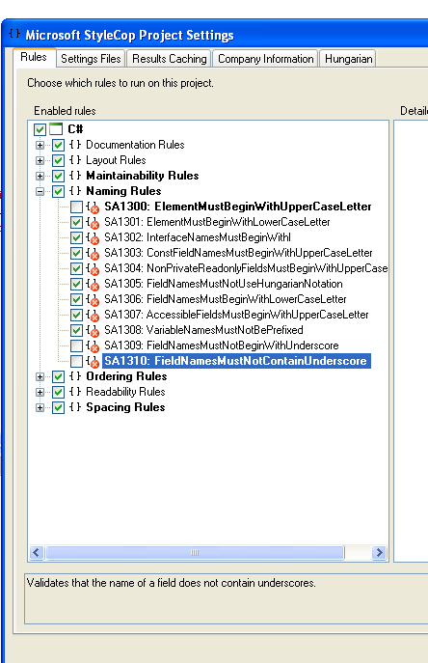
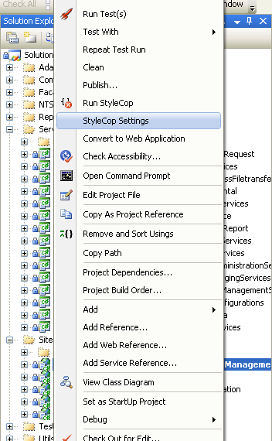

When should warnings be suppressed?
In newly developed code, no warnings should be suppressed except the rules suppressed globally, see the next paragraph. When StyleCop is applied to old code, some rules may need to be suppressed so as not to change too much code.

Global suppressions
There is a global StyleCop.settings file in SESAMM Tool where some rules are disabled.
The table below shows which rules are suppressed:

Element Documentation
SA1600: ElementsMustBeDocumented | Validates that an element contains a properly formatted documentation header.
SA1609: PropertyDocumentationMustHaveValue | Validates that a public or protected property contains a documentation header with a value tag.
SA1610: PropertyDocumentationMustHaveValueText | Validates that a property's value tag contains a filled-in description.
SA1628: DocumentationMustBeginWithACapitalLetter | Validates that the documentation text within a documentation section begins with a capital letter.
SA1629: DocumentatinMustEndWithAPeriod | Validates that the documentation text within a documentation section ends with a period.
SA 1642: ConstructorSummaryDocumentationMustBeginWithStandardText | Validates that the documentation text within the constructor begins with a standard text.
FileHeaders
SA1633: FileMustHaveHeader | Validates that a file contains a properly formatted file header.
SA1634: FileHeaderMustShowCopyright | Validates that a file header contains a copyright tag.
SA1635: FileHeaderMustShowCopyrightText | Validates that a file header contains a filled-in copyright tag.
SA1637: FileHeaderMustContainFileName | Validates that a file header contains a file attribute.
SA1638: FileHeaderFileNameDocumentationMustMatchFileName | Validates that a file header contains a file attribute which contains the name of the file.
SA1639: FileHeaderMustHaveSummary | Validates that a file header contains a filled-in summary description.
SA1640: FileHeaderMustHaveValidCompanyText | Validates that a file header contains a filled-in company attribute.
SA1650: ElementDocumentationMustBeSpelledCorrectly
Naming Rules
SA1309: FieldNamesMustNotBeginWithUnderscore | Validates that the name of a field does not begin with an underscore.
OrderingRules
SA1200: UsingDirectiveMustBePlacedWithinNamespace | Validates that all using directives are placed within a namespace, if a namespace exists in the file.
SA1208: SystemUsingDirectivesMustBePlacedBeforeOtherUsingDirectives | Validates that system using directives are placed first.
Readability Rules
SA1101: PrefixLocalCallWithThis | Verifies that the 'base.' prefix is not misused.
SA1126 : PrefixCallsCorrectly | A call to a member is not prefixed with the 'this.', 'base.', 'object.' or 'typename.' prefix to indicate the intended method call, within a C# code file.
.

References
StyleCop https://www.nuget.org/packages/StyleCop.MSBuild

